**MAT 442: HMW 5**

1. Example 3 on page 7, we check the stability of the 2-cycle for the **Ricker model**: For *a* = 9 , *b* = 5 and

*yk*+1 = *ayke*−*byk, a >* 1*.*

Using the cobweb method we obtain

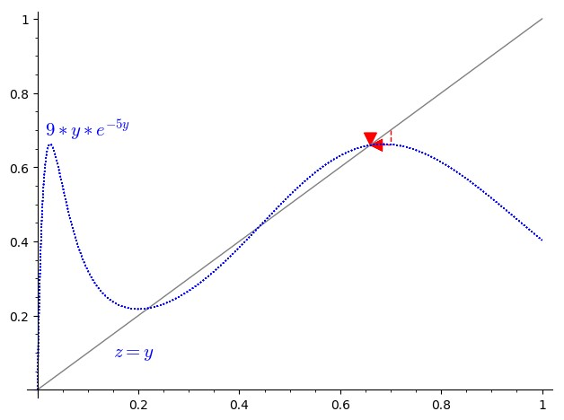

Figure 1: Cobweb diagram with r = 0.7

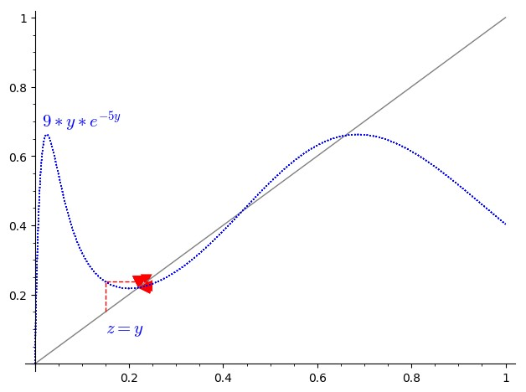

Figure 2: The cobweb diagram above is to show the stability of our 2-cycle. From our LN on periodic doubling and chaos we know that the orbit of 2-cycle point is also called a 2-cycle.Looking at the graph we see that there are four intersection, two of which must be the fixed points and the remaining two is a 2-cycle.The equilibrium points are {0,17*/*40} and we found that {1*/*5,13*/*20} is the 2-cycle.Looking at the graph, we clearly can see the cobweb attracting towards 11*/*50.One interesting thing about how this attraction is that, it depends on the *r*.Let say if we chose our *r* = 0*.*7 like in figure 1 above the cobweb will be attracting to 13*/*20 which satisfies the fact that, if one point is attracting others will attract.

2. We find all the equilibrium points and 2-cycles for DE

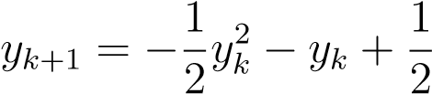*.*

To find equilibrium points, set

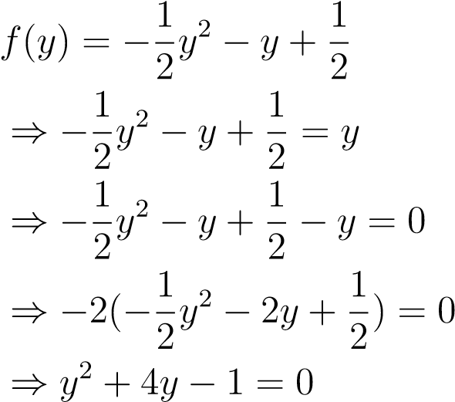

Using the quadratic formula we obtain

−4 ± p42 − 4(1)(−1) *y* =

2(1)

√

−4 ± 20

=

2

√ = −2 ± 5 *.*

The derivative of

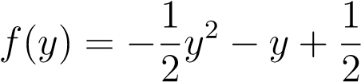

is

*f*0(*y*) = −*y* − 1 *.* Then



and

*.*

Now to check whether the fixed points its stable or unstable, we set

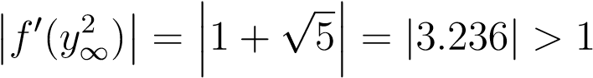

Hence, our fixed points *y*∞1 ,*y*∞2 are unstable.To check the stability of

2-cycle, we have

|*f*0(−1)*f*0(1)| = |(1 − 1)(−2)| = |(0)(−2)| = 0 *<* 1

Therefore the 2-cycle is LAS.

3. Finding the values of *a*, *b* ∈ IR for which {0*,*1} is an LAS 2-cycle for the function

*f*(*y*) = *ay*3 − *by* + 1

we set

*f*(*y*) = *ay*3 − *by* + 1 = *y*

⇒ *ay*3 − *by* + *y* + 1 = 0

⇒ *ay*3 − (*b* + 1)*y* + 1 = 0*.*

Now substitute 0 and 1 into our function to obtain

*f*(0) = *a*(0)3 + *b*(0) + 1 = 1

and

*f*(1) = *a*(1)3 + *b*(1) + 1 = *a* + *b* ⇒ *a* = *b* − 1

so clearly there is some relation between *a* and *b*.

We compute the derivative of *f*

*f*0(*y*) = 3*ay*2 − *b*

then

*f*0(0) = −*b* = −(*a* + 1) = −*a* − 1 (because *a* + 1 = *b*)

and *f*0(1) = 3*a* − *b* = 3*a* − *a* − 1 = 2*a* − 1*.*

Now we consider

|*f*0(0)*f*0(1)| = (−*a* − 1)(2*a* − 1) = −2*a*2 + *a* − 2*a* + 1 = −2*a*2 − *a* + 1*.*

and as always we set

−1 *<* −2*a*2 − *a* + 1 *<* 1 ⇔ 0 *<* 2*a*2 + *a <* 2

Since we have LHS(case 1) and RHS(case 2) of the inequality, we consider

**Case 1** : 0 *<* 2*a*2 + *a* we know that coefficient of *a*2 is greater zero which gives an open up parabola shape.

**Case 2** : 2*a*2 + *a <* 2 using the quadratic formula we derive

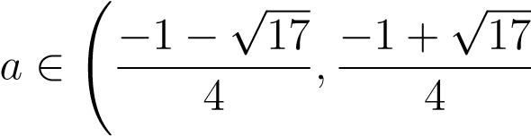!

Now we merge the solutions of both cases by union in order to know which interval *a* and *b* belongs to, so we obtain

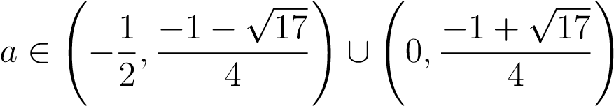 *.*

Because *a* + 1 = *b*,we also get

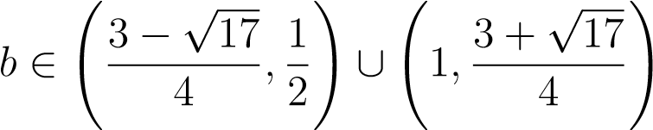 *.*

4. Graphically deciding whether there are 3-cycles for the discrete logistic model *yk*+1 = 3*.*828*x*(1 − *x*)*.*

1. Using the cobweb method, we get

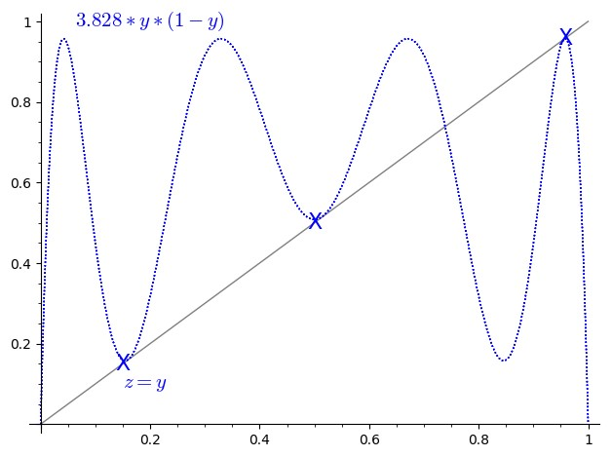

Figure 3: The graph above shows the existence of 3-cycle.We can clearly see our curve intersecting with line *z* = *y* at various points on the graph.I have marked the various points with X on the graph for easy indication.

1. From the graph above we can see that our 3-cycles are {0.2,0.5,1.0} which is approximated numerical values for the 3-periodic points seen on the graph(which is marked in X).

# References

[1] Dynamical Systems for Biological Modeling: An Introduction by Brauer and Kribs, CRC Press, 2016. ISBN 978-1-4200-6641-8